# Results additional questions – Maximilian Leitschuh

1. Does more required work experience increase the likelihood of a higher salary?
   1. What are the differences between the length of required work experience in relation to average salary?

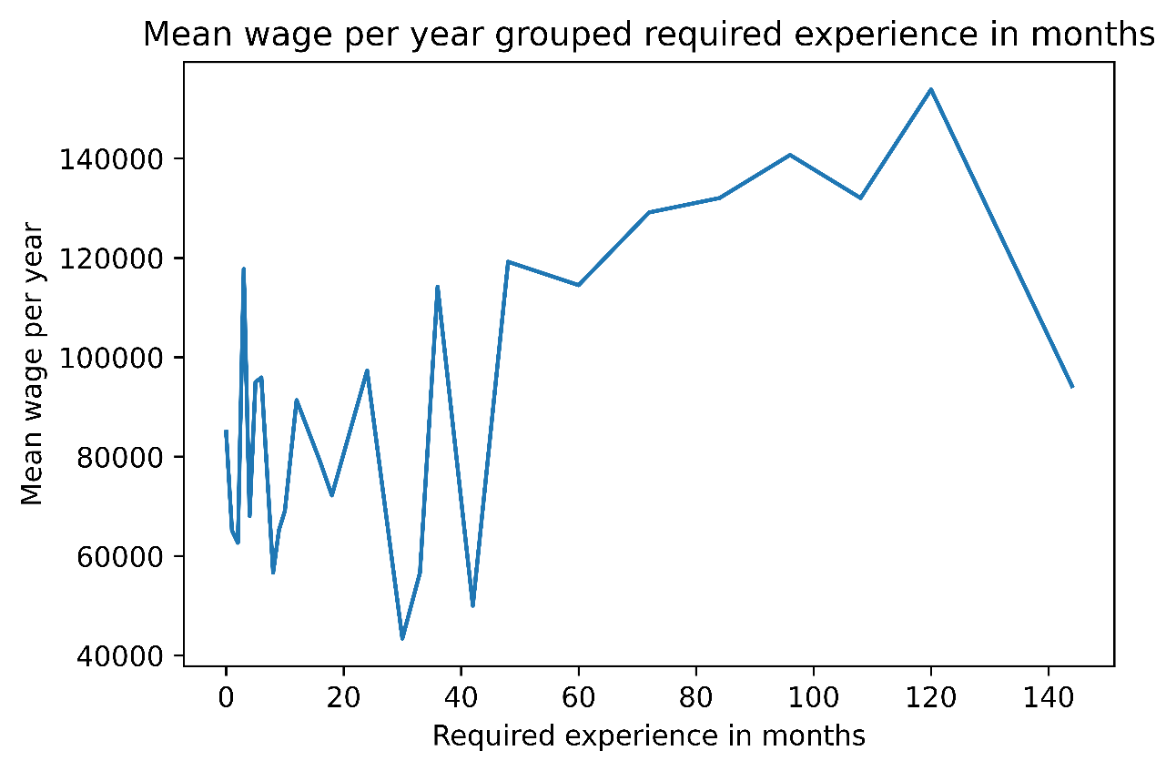

* 1. Do you earn more at a company that requires work experience?

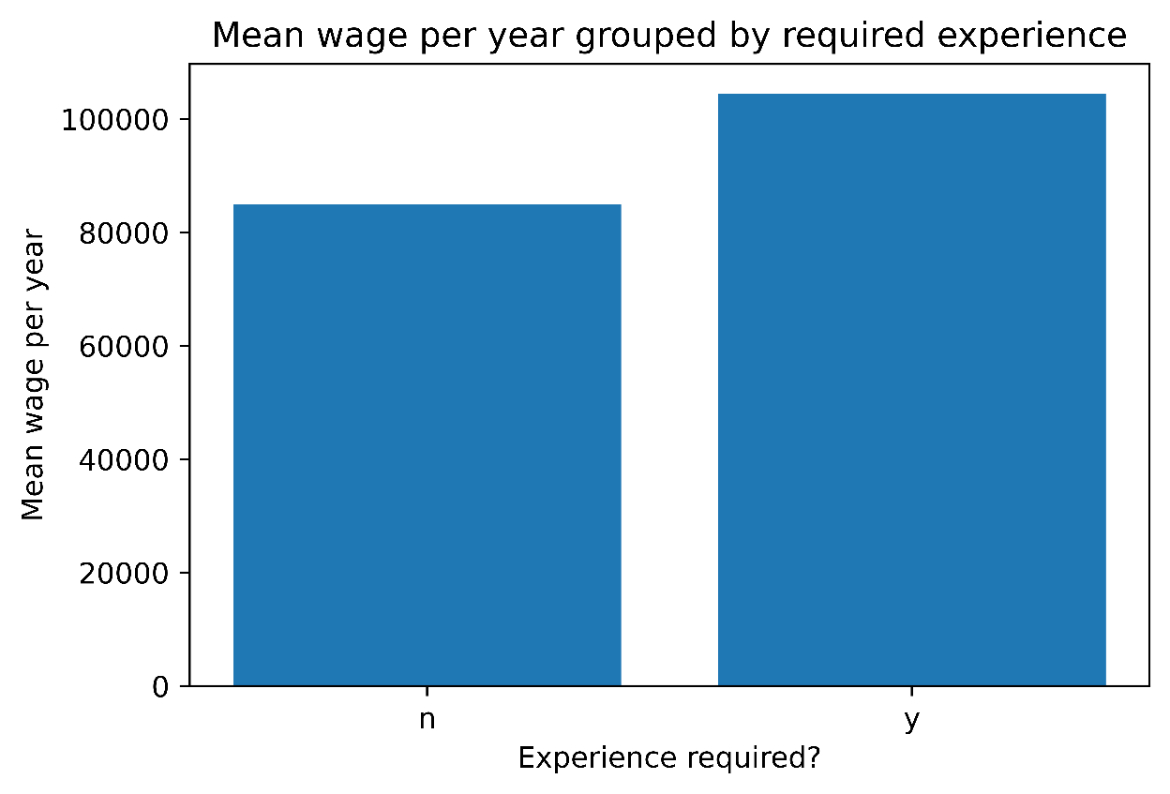

* 1. What is the rate of companies in the tech industry that require work experience and what is the mean salary?
     1. 3.95% in the tech industry require work experience

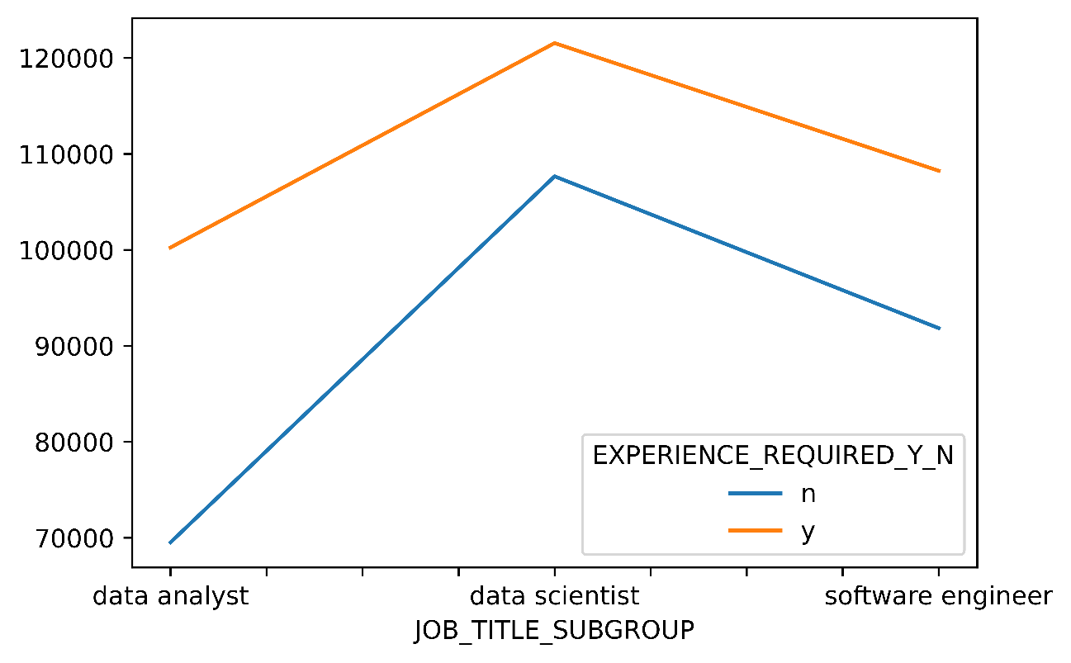

1. Does better required education increase the likelihood of a higher salary?
   1. What are the differences between different levels of education in terms of average salary?

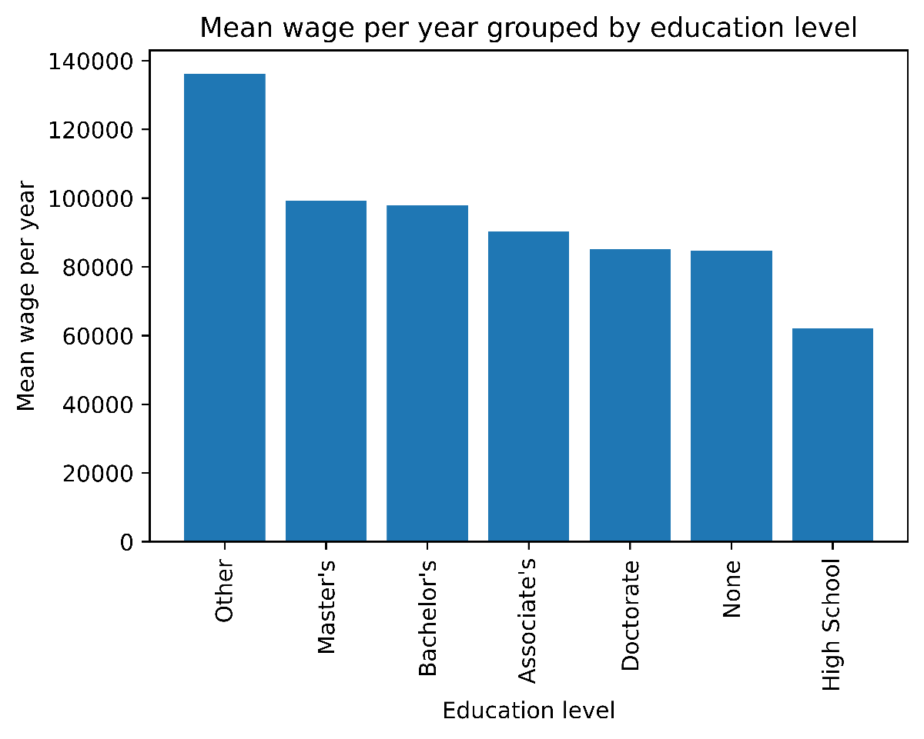

* 1. Do you earn more at a company that requires a college degree?
     1. 6.61% require a college degree

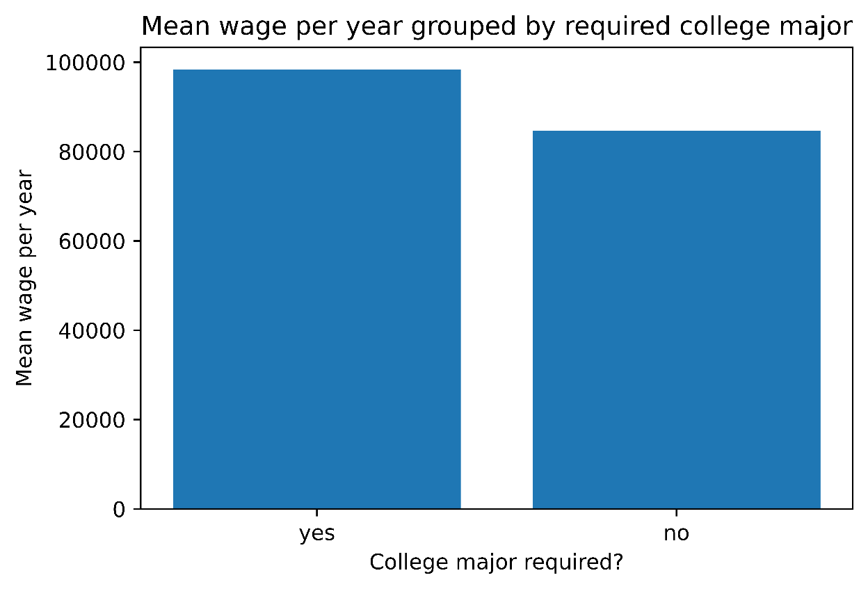

* 1. What is the rate of companies in the tech industry that require a college major and what is the average wage?
     1. 7.70% of the companies in the tech industry require a college major

